**Abstract:-** The scarcity of clean water resources around the globe has generated a need for their optimum utilization. Internet of Things (IoT) solutions, based on the application specific sensors’ data acquisition and intelligent processing, are bridging the gaps between the cyber and physical worlds. IoT based smart irrigation management systems can help in achieving optimum water-resource utilization in the precision farming landscape. This paper presents an open-source technology based smart system to predict the irrigation requirements of a field using the sensing of ground parameter like soil moisture, soil temperature, and environmental conditions along with the weather forecast data from the Internet. The sensing nodes, involved in the ground and environmental sensing, consider soil moisture, soil temperature, air temperature, Ultraviolet (UV) light radiation, and relative humidity of the crop field. The intelligence of the proposed system is based on a smart algorithm, which considers sensed data along with the weather forecast parameters like precipitation, air temperature, humidity, and UV for the near future. The complete system has been developed and deployed on a pilot scale, where the sensor node data is wirelessly collected over the cloud using web-services and a web-based information visualization and decision support system provides the real-time information insights based on the analysis of sensors data and weather forecast data. The system has a provision for a closed-loop control of the water supply to realize a fully autonomous irrigation scheme. The paper describes the system and discusses in detail the information processing results of three weeks data based on the proposed algorithm. The system is fully functional and the prediction results are very encouraging.

**Introduction:-**  Water scarcity is already affecting a part of the world and the situation is getting worse over time due to the increasing world population and fresh water demands. The current world population is around 7.2 billion and it is expected to be more than 9 billion by 2050 (United Nations, 2013). The agriculture sector, particularly irrigation, consumes a major portion of the freshwater. Due to lack of cost-effective intelligent irrigation systems, developing countries are consuming more water in contrast to the developed countries for achieving the same yield. For example, India has approximately 4% of world’s freshwater resources to serve 17% of the world population; however, it takes 2–4 times more water for some of its major agri-produce in comparison to the other countries like China, USA (G. o. I. NITI Aayog, 2015). Therefore, there is a dire need to come up with advanced technologies based smart strategies and systems for effective utilization of fresh water.

Gubbi et al. (2013) discussed an IoT framework with cloud centric storage, processing and analysis of the data received from ubiquitous sensors along with a decision support interface. Cruz et al. (2018) suggested a reference model for an IoT middleware platform that would support intelligent IoT applications. IoT based solutions are proving very helpful in many dimensions of the agricultural landscape (Sharma et al., 2016), and these intelligent solutions could also be fruitful in smart irrigation with optimum utilization of water. Soil moisture, precipitation, and evaporation are the essential parameters for designing a smart irrigation system. The precipitation and evaporation are important key factors, which influence the soil moisture. In geography and climatology, the wetness of soil is estimated by the proportion of annual (or monthly) precipitation and evaporation (Shang et al., 2007). Daily soil moisture can also be evaluated by the ratio of daily precipitation and evaporation in the above perspective. Precipitation is directly accessible in the routine weather reports; nonetheless, evaporation can be calculated using other metrological essentials. For evaporation, we use an empirical model given by Penman (Chen and Chen, 1993).

ET (Eh + Em) (1)

The entire evaporation (ET) depends on the thermodynamic evaporation (Eh) and the dynamic evaporation (Em), where Em depends upon the velocity of the land storm, air temperature, relative humidity of the air and UV radiation. To achieve water saving, irrigation system frameworks have been proposed based on various techniques, e.g., thermal imaging, Crop Water Stress Index (CWSI), direct soil water measurements, etc. Thermal imaging is a prominent technique for irrigation management and it is based on the shade temperature distribution of the plant. In this framework, the status of the water in the plant is checked over continuous intervals and irrigation is planned in view of the shade temperature distribution of the plant (Wang et al., 2010). In addition, CWSI based framework has been proposed for irrigation scheduling of the crops for efficient use of water. The observation of CWSI was first characterized more than 30 years ago (Idso et al., 1981). O’Shaughnessy and Evett (2010) proposed an automatic irrigation scheduling based on direct soil water measurement that utilizes water proficiently over manual irrigation system. Allen et al. (1998) suggested evapotranspiration (ET) based approach, which is an important parameter to decide crop irrigation needs influenced by climate parameters, e.g., solar radiation, relative humidity, temperature, wind velocity, and crop features such as phase of the crop growth, assortment and plant density, properties of soil, nuisance, and disease control. ET-based frameworks can save water up to 42% over time-based water irrigation scheduling (Davis and Dukes, 2010). Davis et al. (2009) conducted the investigations in Florida and verified that ET‐based watering scheduling controllers are more beneficial in term of cost, size and labor requirement for irrigation. ET-based irrigation system uses much less water as compared to scheduled practices. Viani et al. (2017) proposed a fuzzy logic-based decision support system based on farmer’s experience with the understanding of crop condition. This system provides more water saving over single-threshold and multi-threshold based irrigation scheduling. Gutiérrez et al. (2014) proposed an automated irrigation system using a wireless sensor network and GPRS module to save water in irrigation. In this system, a network of soil moisture sensors with controller has been installed in a crop field for real-time monitoring and irrigation control. Gill et al. (2006) suggested a method for soil moisture prediction using support vector machines based on air temperature, relative air humidity and soil temperature. Jaguey et al. (2015) developed irrigation sensor based on smart phone. For sensing soil moisture, the digital camera of smart phone is used to process RGB to gray for estimation of ratio between wet and dry area of soil. The ratio of wetness and dryness is transmitted via gateway to water motor controller. A Mobile Application (APP) is developed to control sensor activity (like wakeup) and to set sensor in sleep mode. Goldstein et al. (2017) proposed irrigation recommendations based on machine learning algorithm with support of agronomist’s encysted knowledge. It was found that the best regression model was Gradient Boosted Regression Trees (GBRT) with 93% accuracy in prediction of irrigation plan/recommendation. The developed model is helpful to the agronomist’s irrigation management. Roopaei et al. (2017) proposed an intelligent irrigation monitoring system based on thermal imaging. The proposed technique uses thermal imaging camera mounted on Drone. An algorithm is developed using images processing techniques for identification of water requirement, Leaf water potential, and nonuniform irrigation, which are used for irrigation monitoring. Majority of the earlier irrigation systems do not consider the weather forecasting information (e.g., precipitation) while making irrigation decisions. It leads to a wastage of fresh water, energy and loss of crop growth (due to excess water) when a rain is followed immediately by the watering of the crop. To handle such cases, IoT based solutions can provide a better decision support for irrigation by utilizing weather forecasting information (e.g., precipitation) from the Internet. Further, the accuracy of weather forecasting is improving due to the advancement of satellite imagery technology. For effective and optimum utilization of fresh water in irrigation, it becomes essential to develop the smart irrigation systems based on dynamic prediction of soil moisture pattern of the field and precipitation information of upcoming days. This paper presents an intelligent system that predicts soil moisture based on the information collected from the sensors deployed at the field and the weather forecast information available on the Internet. The field data has been collected through a self-designed sensor node. The server-side software has been developed with node side connectivity along with information visualization and decision support features. A novel algorithm has been developed for soil-moisture prediction, which is based on Machine Learning techniques applied on the sensor node data and the weather forecast data. The algorithm shows improved accuracy and less error. The proposed approach could help in making effective irrigation decisions with optimum water usage.

**Materials and methods:-**

The test area is located in Punjab, India (E 115˚7’ ~ E 117˚4’, N 39˚4’ ~N 41˚6’), in Patiala district. It represents a typical semi-humid continental monsoon climate in the North Temperate Zone. It is hot and rainy in summer, and is cold and dry in winter. Spring and Autumn are short. The soil texture is mainly sandy soil or resembles sandy soil. Regarding the two areas, Daxing is sandy loam, and Yanqing Shunyi is mostly medium loam. The main crops are winter wheat and summer corn. The average annual rainfall in Beijing is 585 mm, but the regional distribution is uneven, and the overall rainfall is increasing. From 2012 to 2016, the annual soil moisture change in Beijing was between 10% and 25%. The test area covers Beijing’s main planting areas. The proposed model can provide a theoretical basis for water-saving irrigation strategies in Beijing.

The data used in this experiment is provided by the Beijing Meteorological Bureau and is divided into two parts: meteorological data and soil moisture data. The data includes three

areas, Yanqing, Shunyi and Daxing. The period covered by the meteorological data and soil

moisture data is from 2012 to 2016.The meteorological data types include daily average temperature, daily average air pressure, daily average relative humidity, daily average wind speed, daily average surface temperature, and daily precipitation; soil moisture data includes soil average mass water content at 10 cm and 20 cm depth in farmland.

**The implemented system** consists of three components:

the sensor platform,

the server station,

and the end user.

In the sensor platform, it contains sensors that acquire data from environment such as temperature, humidity, atmospheric pressure and Lumosity. These several sensors are pre-installed in the Waspmote device. The information about these sensors is listed below:

**Waspmote** is an open-source wireless sensor platform which is easy and scalable device ensuring minimum maintenance costs. The new platform consists of a robust waterproof enclosure with specific external sockets to connect the sensors, the solar panel, the antenna, and even the USB cable in order to reprogram the node. It has been specially designed to be scalable, easy to deploy and maintain. It is a solar-powered rechargeable tool that uses sunlight for the working and has a long battery backup. It has three different sensors such as soil moisture, humidity, and atmospheric temperature, and luminosity sensor through which 9 readings are observed which are listed below.

* Watermark1=0.00
* Watermark2=0.00
* Watermark3=0.00
* Temperature=25.06
* Humidity=60.23
* Pressure=97586.56
* Luxes=83.00
* Battery=88

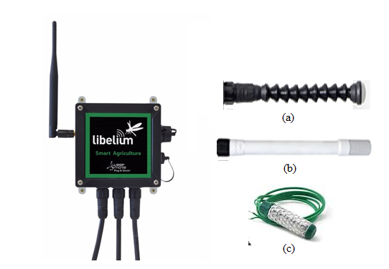

Figure 1: Libelium device and its equipment: (a) Luminosity sensor, (b) Atmospheric temperature and Humidity sensor (c) soil moisture sensor (to be installed at three different depths)

a local processing unit that takes data and assembles them into packets and a wireless data transmission module using the FTP interface for local data communication to the server and the GSM for the battery level indication.

The system can thus be configured to communicate either to a server at a

About soil moisture:-

Soil moisture is an important variable in the precision agriculture to understand the properties of the soil and crop. The soil moisture is a composition of the soil particles, water and the air. The measurement of the soil is depend upon the type of the soil and the availability of the water. The high level of the soil moisture resulted with the root diseases and the wastage of the water alternatively the lower level of the soil moisture causes the loss in productivity and the decaying of the plant. Hence the water is called as an important nutrient element of the soil and also the health of the plant. Whether these nutrients are delivered to the field through the irrigation system or through other means, movement of water within the soil governs how they are delivered to the plant roots.

The variability in the soil moisture can be understood from the below Figure 1. In the several types of soil such as clay, sandy and the silt soil.

6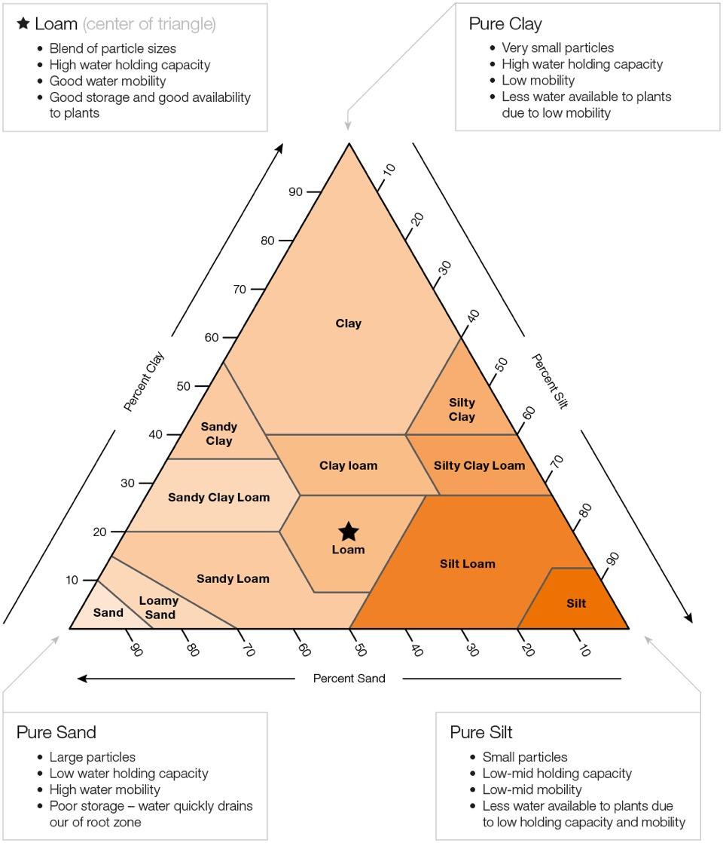

According to the requirements of FMIPNAQS, six national air quality auto-monitoring stations were built in Fuzhou (identified by red in Fig. 2). The station located in Gu Mountain provides the background concentrations of air pollutants as a baseline, while the other 5 stations located in Wusi North road, Ziyang Road, Fujian Normal University, Yangqiao West Road, and Kuai’an are intentionally placed very near major thoroughfares. Those location of the stations were set in ac-cordance with the Ambient Air Quality Monitoring Standards of China and were recognized by China’s MEP. A series of instruments are deployed at each station for auto-mon-itoring and collecting data. Levels of nitrogen oxide (NO-NO2-NOx) emissions in ambient air are measured using chemiluminescent tech-nology with the Thermo Scientific™ Model 42i NO-NO2-NOx Analyzer; levels of SO2 are measured in ambient air up to 100 ppm with the Thermo Scientific™ Model 43i SO2 Analyzer; ambient air monitoring instruments are calibrated with the Thermo Scientific™ Model 146i Multi-Gas Calibrator, which can generate gas standards; and PM2.5 and PM10 airborne particulates are monitored by the Thermo Scientific™ 1405 TEOM™ Continuous Ambient Particulate Monitor. All the pollu-tants mentioned above are auto-monitored once every 5 min, thus the total number of samples taken from August 2014 through July 2016 were about 1,260,000, and the monthly mean concentrations of these pollutants were announced by CNEMC (CNEMC, 2014).

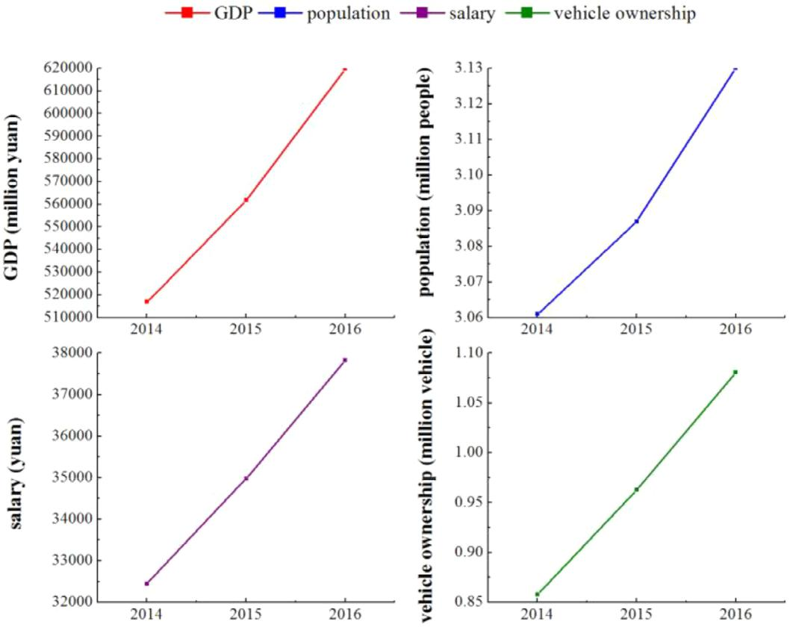

**2.2 Data processing and analysis**

Different sources of meteorological data and soil moisture data result in different data formats

and lengths. Data integration and matching is required. The deep learning model requires a

large amount of data for training purposes and a long time-span data set to ensure complete

data characteristics. The method involves selecting the training set and test set according to

the amount of soil moisture data from 2012 to 2016. The integrated data contains missing values. If the missing value is included, and induces a large error, it will cause interference in the model training. Therefore, we chose to eliminate data with missing values. The final data set contains six meteorological features, as well as an initial moisture feature, and a pending prediction feature of soil moisture. After processing, a total of 1,196 data samples from Yanqing area were obtained, including 954 sets of data from 2012 to 2015 to build a training set, 242 sets of data in 2016 to build a test set, and 50 data samples were randomly selected from the test set for model selection. At the same time, a total of 239 data from Shunyi area in 2016 and 235 data from Daxing area in 2016 were used to verify the extensibility of the model.

To predict the data, we must first understand the trend of the predicted features. According

to Fig 1, the water timing chart of the four years from 2012 to 2016, although the moisture data fluctuates greatly, presenting a periodical status overall, generally from July to September each year represents the data peak, the maximum soil water content is up to 25.6%. From November to February of the next year indicates the period for minimum water content, which is only 7.50%. However, different years show large discrepancies because of different meteorological conditions. Facing such complex prediction features, deep learning is suitable for soil moisture prediction because of its data fitting capabilities.

**2.3 Correlation analysis: Spearman’s rho test**

Spearman’s rho test was used to determine the degree of correlation between the values of PM2.5 and the values of other criteria pollutants (SO2, NO2, PM10) and meteorological data (rainfall, temperature, humidity). Spearman’s rho, generally represented as rs (Spearman, 1904), is a non-parametric indicator that measures the dependence between the rankings of two variables. Spearman’s rho tests linear or non-linear monotonic relationships (Mohammad et al., 2017). If there are no duplicate values in the data and the two variables are completely monotonically related, the Spearman correlation coefficient is either +1 or −1, each of which represents the highest correlation, positive or negative, between two variables. As |rs| approaches 1, the degree of the correlation between Xi and Yi is higher; otherwise, it is lower. PM2.5 concentrations are the variable of interest in this study and are therefore identified as Xi, where i runs from 1 to 24 for the months from August 2014 through July 2016. The other pollutant values and meteorological data are identified by Yi. Then Xi, Yi were converted to rank data xi, yi , and rs was calculated from:

|  |  |  |  |  |  |  |
| --- | --- | --- | --- | --- | --- | --- |
| *rs* = | ∑*i* (*x* *i* −*x*¯)(*yi* −*y*¯) | | |  | | |
| ∑ | (*x* *i* −*x*¯) 2 ∑ | (*y* −*y*¯)2 | (1) | | |
|  |
|  | *i* | *i* | *i* |
| **Epoch Time** | | | | | **Soil Moisture at 15 m** | **Soil Moisture at 45 m** | | **Soil Moisture at 80 m** |
| 946964088 | | | | | 1016.26 | 3448.27 | | 2577.31 |
| 946964215 | | | | | 1018.32 | 3472.22 | | 2564.1 |
| 946694759 | | | | | 2380.95 | 3649.63 | | 1396.64 |
| 946694826 | | | | | 2380.95 | 3649.63 | | 1396.64 |
| 946694893 | | | | | 2380.95 | 3649.63 | | 1396.64 |
| 946694960 | | | | | 2380.95 | 3649.63 | | 1392.75 |
| 946695027 | | | | | 2380.95 | 3649.63 | | 1392.75 |
| 946695094 | | | | | 2403.84 | 3649.63 | | 1392.75 |
| 946695161 | | | | | 2392.34 | 3649.63 | | 1392.75 |
| 946695228 | | | | | 2392.34 | 3649.63 | | 1392.75 |
| 946695295 | | | | | 2392.34 | 3649.63 | | 1392.75 |
| 946695362 | | | | | 2392.34 | 3649.63 | | 1392.75 |
| 946695429 | | | | | 2392.34 | 3649.63 | | 1392.75 |
| 946695496 | | | | | 2403.84 | 3649.63 | | 1392.75 |
| 946695563 | | | | | 2403.84 | 3649.63 | | 1392.75 |
| 946695630 | | | | | 2403.84 | 3649.63 | | 1392.75 |
| 946695697 | | | | | 2403.84 | 3649.63 | | 1392.75 |
| 946695764 | | | | | 2403.84 | 3649.63 | | 1392.75 |
| 946695831 | | | | | 2403.84 | 3649.63 | | 1392.75 |

**2.4 ARIMA Model:**

An ARIMA model is a time-sequence prediction method. The time series data formed by the samples over time is treated as a random sequence, which is described, approximately, by a mathematical model. Once being recognized, the model can be used to predict future values of the time sequence based on its past and present values. The ARIMA model consists of three parts.

The “AR”, the auto-regressive part, indicates that the evolving variable of interest is re-gressed on its previous values; the “MA” part, the moving average part, indicates that the regression error is actually a linear combination of error terms whose values occurred contemporaneously and at various times in the past; the “I”, the integrated part, indicates that the data values have been replaced with the diﬀerence between their values and the previous values.

The purpose of each of these features is to make the model fit the data as well as possible. The ARIMA model is generally denoted ARIMA (p,d,q) where “p” is the order of the autoregressive model, “d” is the degree of diﬀerencing, and “q” is the order of the moving-average model. The ARIMA model can be estimated following the Box–Jenkins approach:

|  |  |  |  |  |  |  |  |
| --- | --- | --- | --- | --- | --- | --- | --- |
|  | *p* |  |  |  | *q* |  |  |
|  | (1−*L* ) *d* *Xt* = | + ∑ *θi* *Li* | *εt* |
| 1 - ∑ *ϕi* *Li* | |  | 1 |  |
|  | *i*=1 |  |  |  | *i*=1 |  | (3) |